**Governor Ron DeSantis Awards $1.5 Million to Winter Haven Through the Job Growth Grant Fund to Expand Rail Access at the Central Florida Integrated Logistics Park**

March 10, 2025

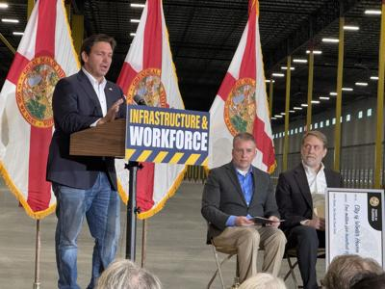

**WINTER HAVEN, Fla.—**Today, Governor Ron DeSantis awarded $1.5 million to Winter Haven to extend rail access within the Central Florida Integrated Logistics Park through the Florida Job Growth Grant Fund (JGGF). This rail extension will help businesses expand operations in the area, creating 200 jobs.   
  
“Today’s award will make it easier to invest, operate, and relocate in Central Florida,” **said Governor Ron DeSantis.** “This strategic transportation investment, combined with our ongoing Moving Florida Forward initiative, will eliminate supply chain bottlenecks and boost shipping capacity along the I-4 corridor, supporting businesses and strengthening our economy.”   
The Central Florida Integrated Logistics Park is 930 acres of developable land that can accommodate over 8 million sq. ft of development in close proximity to major thoroughfares and a dedicated CSX Rail Intermodal Facility. The center’s utilities can accommodate a wide variety of users from food and cold storage to manufacturers and statewide logistics companies. These businesses include a well-known fast-food company, which announced it will establish a cold storage facility at the logistics center.  
  
“I’m grateful for Governor DeSantis’ leadership in recognizing both the crucial role that Florida’s railways play in the state’s economic success and the positive effect further expanding them can have,” **said Secretary of Commerce J. Alex Kelly.**“Extending this rail line will help retain current businesses who use the line and attract new job creators and job seekers.”   
  
The Florida Job Growth Grant Fund is an economic development program designed to promote public infrastructure and workforce training across the state. Proposals are reviewed by FloridaCommerce and are chosen by Governor DeSantis to meet the demands for workforce training or infrastructure needs in communities around the state.  
  
For more information on the Job Growth Grant Fund, [**click here.**](https://t.e2ma.net/click/wq5lkp/0dims2r/gi42sqb)